Tina Avionics System Requirements


System overview

The avionics system will be responsible for logging telemetry data during launch. This also includes systems in place for detecting launch, apogee, and descent, and triggering deployment events.
While the main Flight Computer designed for Tina is supposed to be composed of 5 custom boards, this flight, due to time constraints, will only fly with the redundant flight computer using the following boards:
- Power Board
- Redundant Flight Computer (primary decision-making + pyro control)
- Sensor Board (provides IMU, barometer; redundant IMU also available on flight computer)

Configurable Parameters -
No SD card on board; however, these are defined in a global config file
Parameter Name | Description | Units | Default Value | Notes
TLOG_DEBUG | Enabled or disabled Debug mode, which allows sending variable messages | On or off | On
LOG_INTERVAL_LENGTH_MS | Interval between repetitive messages, e.g. IMU fails (not to clutter) | ms | 1000
TELEMETRY_INTERVAL_MS | Interval between all non repetitive logs. | ms | 30 | Dependent on the radio device, 30ms was found to be good
HISTORY_SIZE | Moving average filter size for all components | Size of array | 50
LAUNCH_ACCEL_THRESHOLD_MS2 | Minimum acceleration to detect launch | ms^2 | 30 | Used in launch detection logic
LAUNCH_ALTITUDE_THRESHOLD_M | Minimum altitude to detect launch | m | 5 | Alternative trigger if accel not sufficient
APOGEE_COUNTDOWN_SIZE | Minimum num of times apogee detected (used for logic) | value | 30
DELTA_PRESSURE_FOR_APOGEE_DETECTION_PA | Delta pressure difference for apogee detection, for some wiggle room | PA | 150
LAUNCH_TO_APOGEE_TIMEOUT_MS | Maximum time after launch to trigger drogue if apogee not detected | ms | 20000 | Safety backup
APOGEE_TO_MAIN_TIMEOUT_MS | Maximum time after drogue deployment to trigger main if not detected yet | ms | 6500
MAIN_DEPLOY_ALTITUDE | Altitude to deploy the main chute | m | 100

Hardware Interfaces

2.1 Microcontroller: ST Nucleo-F042K6
- Microcontroller: STM32F042K6
- Architecture: ARM® Cortex®-M0
- Clock Speed: 48 MHz
- Flash Memory: 32 KB
- RAM: 6 KB
- Operating Voltage: 3.3V
- GPIO Pins: 32
- Communication Interfaces: I2C, SPI, UART
- Debugging Interface: ST-LINK/V2-1
We will be using the STM32 Cube IDE to program this board. For specifications and documentation, refer to the NUCLEO-F042K6 Product Page

2.2 Sensors

Barometer: BME280
- Type: Humidity, Pressure, and Temperature Sensor
- Interface: I2C
- Operating Voltage: 1.71V to 3.6V
- Accuracy:
  - Temperature: ±1.0°C
  - Pressure: ±1 hPa
  - Humidity: ±3% RH
- Altitude Measurement: ±1 meter accuracy
For specifications, refer to the BME280 Datasheet

Inertial Measurement Unit (IMU): BNO055
- Type: 9-Axis Absolute Orientation Sensor
- Sensors Included:
  - Accelerometer: 14-bit, ±2g to ±16g
  - Gyroscope: 16-bit, ±125°/s to ±2000°/s
  - Magnetometer: 3-axis
- Interface: I2C
- Operating Voltage: 2.4V to 3.6V
- Integrated MCU: 32-bit ARM Cortex-M0+
For specifications, refer to the BNO055 Datasheet

GNSS
The GNSS will be excluded from this launch due to time constraints

2.3 Communication
Wio-E5-LE mini Dev Board
- Type: LoRa/LoraWAN wireless communication module
- Microcontroller - STM32WLE5JC
- Frequency Band: 868/915 MHz ISM (region-dependent)
- Interfaces: We will use I2C as told by electronics
- Range: Up to ~10 km line-of-sight (with suitable antenna)
- Operating Voltage: 2.0V – 3.6V (3.3V typical)
- Use in System: Sends telemetry packets from the avionics unit to the ground station via UART link
For specifications, refer to the Lora Datasheet
Two of these modules will be used on launch day, one is on the sensor board, while the other will be connected to a laptop via USB, where the data coming in over radio can be read serially

2.4 Pyro Channels
4 pyro channels exist on the Redundant Flight computer board, used to deploy the drogue and main chutes

State Diagram

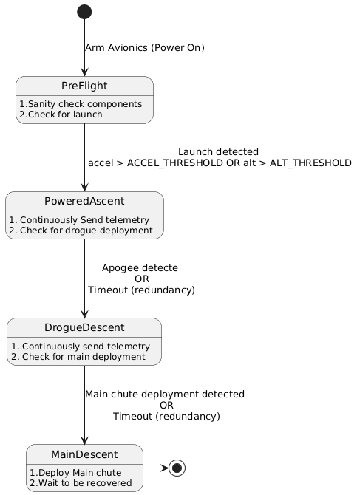

State Transitions

3.1 PreFlight
Entry Condition
Avionics enters the PreFlight stage when the arm switch is activated, in other words, when the unit is powered on
Actions
- Verify communication with IMU and barometer.
- Arm Pyros
- Verify the LoRa telemetry link is operational. This can be verified at the Ground Station by a member
- Perform sensor checks:
  - IMU reports acceleration ≈ -9.81 m/s² (stationary).
  - Barometer provides a valid altitude.
- Report system status to telemetry (low-rate).
Exit Condition

Safety
Before Initiating Launch (physically pressing the button) - It is important that the Sanity check has completed all checks and any errors encountered have been signalled via telemetry

3.2 PoweredAscent
Entry Condition
PreFlight Sanity checks complete, and launch has been detected
Launch Detection Criteria
- Acceleration > +3g
OR
- Altitude > 10m
Actions
- Continuously log data the SD card at a high rate
- Transmit Telemetry over Radio link at a high rate, but at a lower rate than SD card
- The Avionics unit should be able to detect when the rocket has launched
- Log the time of launch

3.3 Drogue Descent
Entry Condition:
Apogee detected or timeout reached. This timeout is a safety mechanism in place to attempt to fire the drogue chute if it has not been deployed after a certain amount of time
Apogee Detection Criteria:
- Altitude does not increase by more than Δh over N samples.
- Vertical velocity ≤ 0 ± ε for N samples. This is just to account for any noise
Actions:
- Fire drogue chute pyro channel.
- Continue logging IMU, barometer, and system state.
- Continue transmitting telemetry data
- Log time of drogue deployment
Safety:
- Timer-based backup: if apogee is not detected after X seconds from launch, automatically fire the drogue chute.
Exit Condition:
- Rocket reaches main chute deployment altitude.

3.4 Main Descent
Entry Condition:
- Drogue chute deployed, descent in progress.
Actions
- Fire main chute pyro channel at configured altitude.
- Continue high-rate logging.
- Transmit telemetry
- Monitor sensor readings to confirm deployment.
- Log time of main chute deployment
Exit Condition:
- Touchdown detected.

3.5 Recovery
Entry Condition:
- Rocket touchdown detected
Touchdown Detection Criteria:
- Acceleration stabilises around -9.81 m/s² for N seconds.
- Altitude remains stable.
Functional Responsibilities:
- Stop all pyro firing. Either block somehow or attempt to fire pyros for safety when the team arrives to pick up the rocket
- Switch telemetry to low-rate.
- Continue logging until powered off.
- Log the time of touchdown
Exit Condition:
- Power off

4.7 Component Diagram

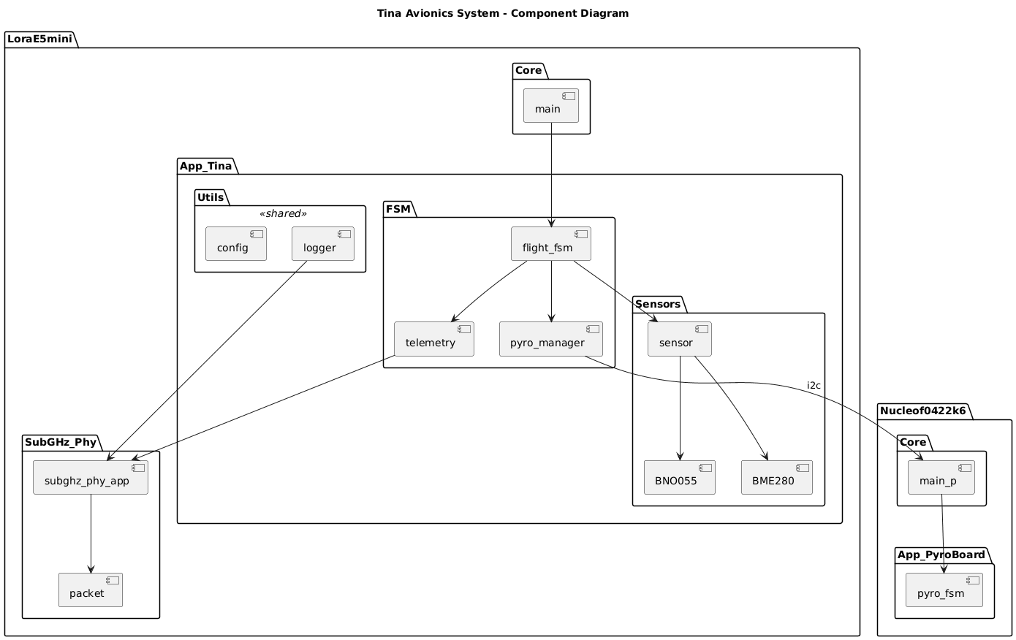

Core
- main – Entry point of the Software, which lives in the core, it runs the main loop and continuously calls the FSM.
FSM
- flight_fsm – Flight state machine - manages PreFlight, Ascent, Drogue, Main, and Recovery states, utilising other modules based on current state
- pyro_manager - manager to communicate with the Pyro board (nucleo board)
- Telemetry - telemetry packet sender

Utils
- config – Loads configuration parameters (thresholds, altitudes, telemetry rates) and provides them to other modules.
- Logger - provides log functions over radio
Sensors
- sensor

6. Telemetry Packet

The packets sent over the radio link have the following structure. It will consist of a main packet that will have the necessary header information, and a payload that can be one of three types: Telemetry, INFO or Error. Telemetry packets are fixed at 28 bytes while INFO can range between 11-27 bytes (it includes its own payload for ASCII text, max 16bytes), and Error packets range from 11-29. All sizes include the main packet, which consists of the header information.

Main Packet

Field Name | Bytes | Type | Description | Notes
HEADER | 1 | uint8 | Packet start marker | 0xAA
SEQ_NUM | 2 | uint16 | Packet sequence number | For packet ordering and loss detection
PACKET_LEN | 1 | uint8 | Length of packet for easy parsing
TIMESTAMP | 4 | uint32 | Time since launch in ms | 4 bytes - 4,294,967,295s = 49 days  2 bytes will be too little - 11mins
PACK_TYPE | 1 | uint8 | A descriptor to determine which packet exists in the payload. Telemetry:0x01,  Error: 0x02
PAYLOAD | N | varies | Depends on PACK_TYPE
CHECKSUM | 1 | uint8 | Simple XOR OR CRC | Covers entire packet except HEADER

Telemetry Packet

Field Name | Bytes | Type | Description | Notes
ACC_X | 2 | int16 | Acceleration X-axis | Scaled by 100 - value in 0.01 g
ACC_Y | 2 | int16 | Acceleration Y-axis | Scaled by 100 - value in 0.01 g
ACC_Z | 2 | int16 | Acceleration Z-axis | Scaled by 100 - value in 0.01 g
GYRO_X | 2 | int16 | Angular velocity X-axis | Scaled by 100 - 0.01 °/s
GYRO_Y | 2 | int16 | Angular velocity Y-axis | Scaled by 100 - 0.01 °/s
GYRO_Z | 2 | int16 | Angular velocity Z-axis | Scaled by 100 - 0.01 °/s
ALTITUDE | 4 | int32 | Barometer-derived altitude | Scaled by 100 - value in cm
EVENT_FLAGS | 1 | uint8 | Bitfield for events | Bit0=Launch, Bit1=Drogue, Bit2=Main, Bit3=Touchdown
SYS_STATE | 1 | uint8 | Avionics state | PreFlight=0, Ascent=1, DrogueDescent=2,  MainDescent=3, Recovery=4

LOG Packet
During launch, variable messages will not be sent over radio, it will stick to message codes which could be error/info codes

Field Name | Bytes | Type | Description
MESSAGE_CODE | 1 | uint16 | message code (lookup table)
MESSAGE_LEN | 1 | uint8 | number of extra bytes
MESSAGE | N | bytes | optional short ASCII

Error Codes
Code | Name | Description
0x01 | IMU_FAIL | BNO055 not responding, bad data, or timeout
0x02 | BARO_FAIL | BME280 missing, invalid read, or checksum error
0x03 | SD_FAIL | Init failure, write error
0x04 | LORA_FAIL | Radio not responding or dropped out
0x05 | PYRO_FAIL | Firing circuit fault
0x06 | CONFIG_ERR | Bad or missing SD config file
0x07 | MISC_ERR | Catch-all for other problems

NOTES

Reasons for scaling sensor outputs:
The reason we scale the IMU and barometer outputs is to preserve two decimal places while using integers. These sensors output floats, but floats are expensive (4bytes per float), so we multiply by 100 and send as an integer. Example: -9.81m/s^2 -> -981 and stored as int16 in packet

Event Flags can represent more than one event fired

The EVENT_FLAGS field is a 1-byte bitfield used to represent flight events in a way that saves space. Each bit corresponds to a specific event:
- Bit0: Launch detected
- Bit1: Drogue chute deployed
- Bit2: Main chute deployed
- Bit3: Touchdown detected
Multiple events can be active simultaneously, the corresponding bits are set to 1. For example, if Launch and Drogue have occurred, the byte value is 0x03.

7. Verification & Testing

7.1 Physical / Hardware Tests
- LoRa Range Test
  - Measure packet loss rate at different distances.
  - Calculate ideal transmission rate for launch
- Pyro Channel Test
  - Confirm firing channels work.
- Sensor Verification
  - IMU: verify accelerometer, gyro, and magnetometer readings
  - Barometer: compare altitude readings using a phone as a reference
- Drone Test
  - Once the Software is ready, Rise will collaborate with the Drone team of UT to test the electronics

8. Pin Mapping
RFC board
STM32 NUCLEO-F042K6
- I2C_SDA PB7
- I2C_SCL PB6
- Pyro_Read_2 PB5
- Pyro_Read_4 PB1
- Pyro_Read_3 PA8
- Pyro_Read_1 PB4
- EN_PYRO4 PA6
- EN_PYRO3 PA5
- EN_PYRO2 PA4
- EN_PYRO1 PA3
Pyro_Read will be LOW when the pyro was fired or the connection to the pyro is broken
PYRO READ WILL BE HIGH WHEN PYROS OFF
IMU: BNO055
- Connected to i2c 0x28
Sensor Board
Barometer: BME280
- Connected to i2d address 0x76
  - Using an i2c scanner i found this, pin
loRa:
- Connected over i2c
Wio-E5-LE mini Dev Board
We may need custom firmware for the lora board to be able to use it

Lora module - Research Kris
To flash the LoRa module, we use an ST-LINK device, which is an STM debugger that allows programming the LoRa-E5 Mini via STM32CubeProgrammer.
Setup:
Pin connections between the ST-LINK and the LoRa-E5 module:
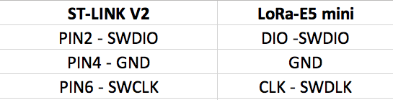
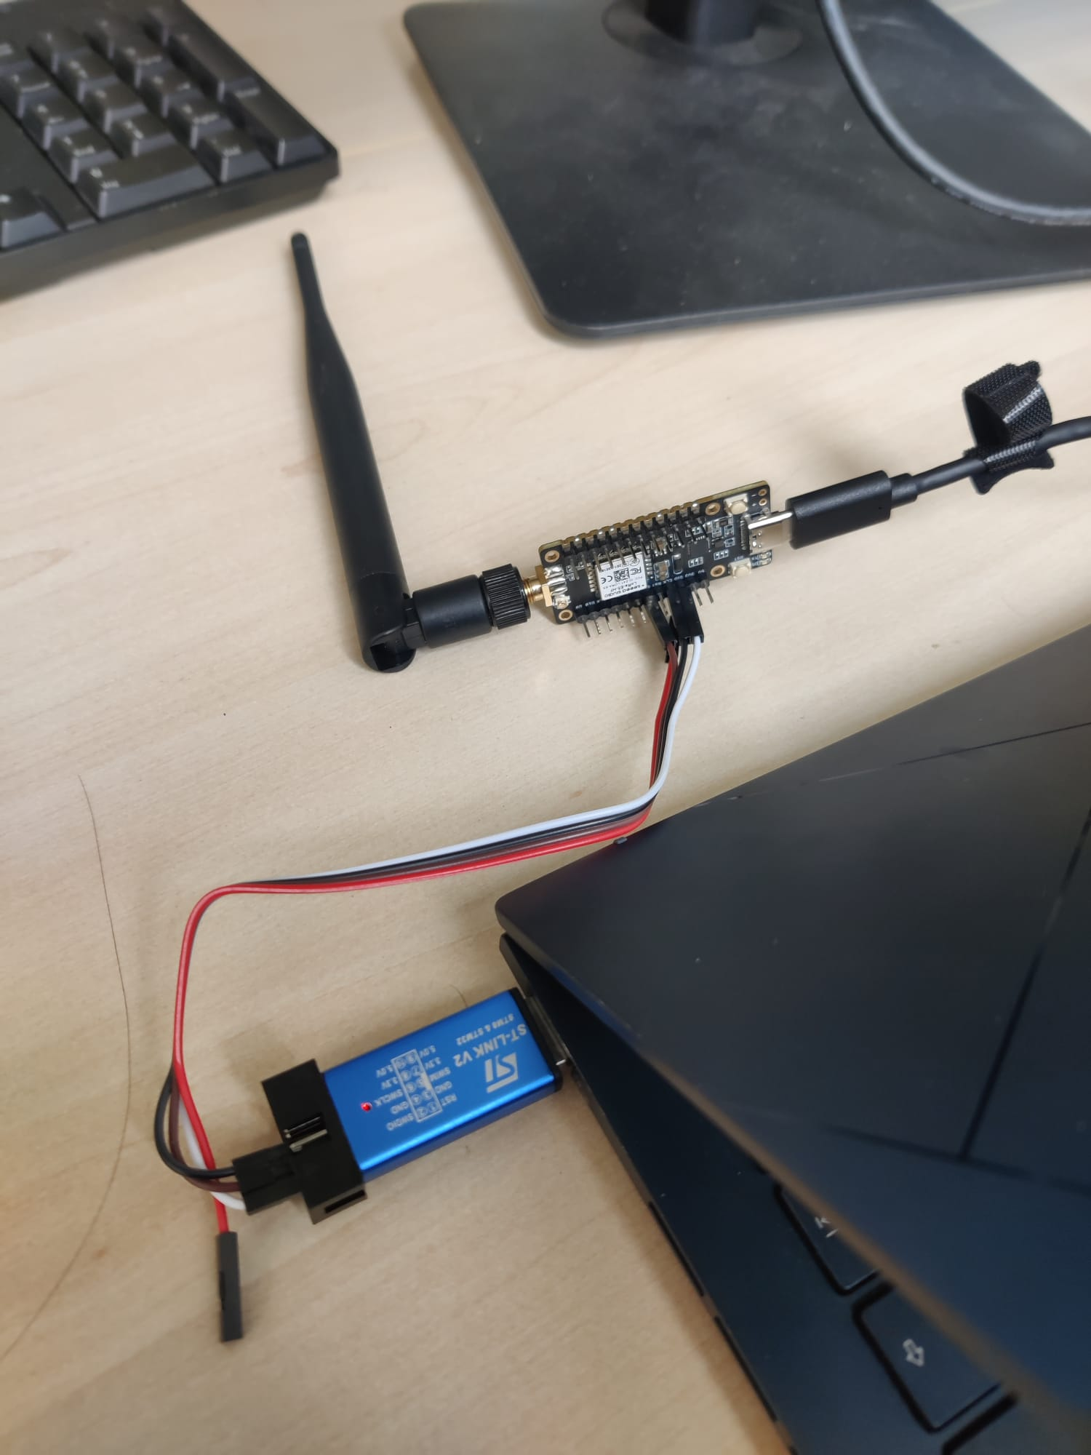
The LoRa module can be powered either from the ST-LINK via the 3.3 V pin or through its USB-C port. It’s best to choose one method for consistency. For programming, I recommend connecting the ST-LINK to the LoRa module using the three SWD pins described above, while also powering the module through its USB-C port.

Connecting to the Lora Module using STMProgrammer:
To connect to the LoRa module. The steps to do so are as follows:
After connecting both the usb c cable and the st link device to the LoRa module, open the Programmer, click on ST-LINK as the connection type, hold down the reset button on the LoRa module and click connect. This will connect to the LoRa module, and if successful, it will read its flash memory
Note: On its first connection, I had to set ROP (Read out protection) to level 0, which erased the base firmware on it (the AT commands firmware), enabling us to program our own firmware on it. This only had to be done once on first time being connected

Running a program on the Lora Module using STM32CubeIDE:
To run a program on the LoRa module, it isn’t strictly necessary to use STM32CubeProgrammer; we can program it directly from STM32CubeIDE. I started by creating a new STM32 project and selected the STM32 chip used on the LoRa module (STM32WLE5JC). It’s important to note that this only initializes the chip in the IDE — all pins still need to be configured according to the peripherals you plan to use.
For example, I began with a simple LED blink program. By checking the LoRa-E5 Mini schematic, I identified that PB5 is connected to an onboard LED, so I configured it as a GPIO output in the .ioc file. After that, I wrote a simple program to toggle the LED on and off.

When unplugging, try unplugging the ST Link first before the USB cable to avoid potential voltage conflicts

Lora e5 mini schematic:
https://files.seeedstudio.com/wiki/Loramini/LoRa-E5%20mini%20v1.0.pdf

Radio Communication Research
This module is commonly used with LoRaWan technoloy, however, we do not want to work with this technology as its not in our interest. We want to work with raw LoRa packets, which will allow us to send many more packets and its better suited for our application
Ping pong raw lora packet - our project was based around this design
https://github.com/STMicroelectronics/STM32CubeWL/blob/main/Projects/NUCLEO-WL55JC/Applications/SubGHz_Phy/SubGHz_Phy_PingPong/SubGHz_Phy/App/subghz_phy_app.c

Enabling Serial Console
Looking at the schematic the lora module uses pins PA9 and PA 10 for usart connected to the usb c port on the module. So i enabled these pins, changed the internal function for io_putchar in the syscalls.c so that printf will automatically send over uart to usb c connector.
UPDATE: This no longer works, as it turns out that the lora breakout board makes use of uart1 for its internal links. We have two options: either attempt to move the internal links on usart 2 in the ioc file. Or use a usb to uart converter and output serially over usart 2(ive already tested this and it works)
To connect serially opena serial console like Putty, connect to your com port with baudrate 115200 and open it.

How to configure AT commands to receive:

Connecting to GCS lora module using AT commands are done through a serial console too, however baudrate must be 9600 to send AT commands
https://files.seeedstudio.com/products/317990687/res/LoRa-E5+AT+Command+Specification_V1.0+.pdf
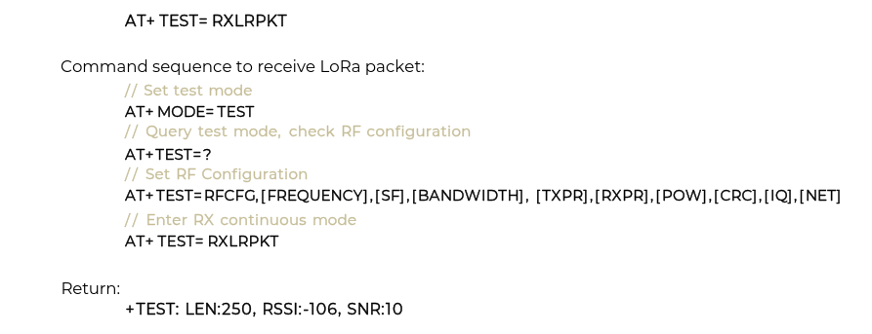
https://github.com/johflo/Seeed-Lora-e5/tree/main/Seeed-LoRa-E5_PingPong

Schematics

Power Board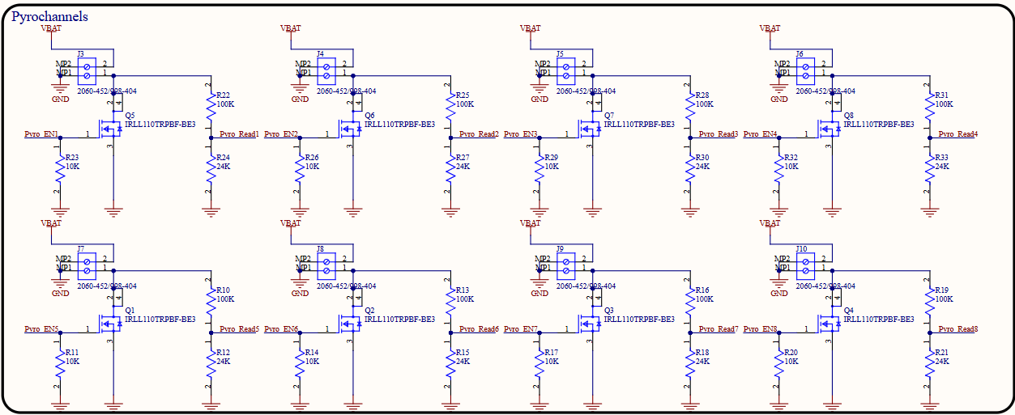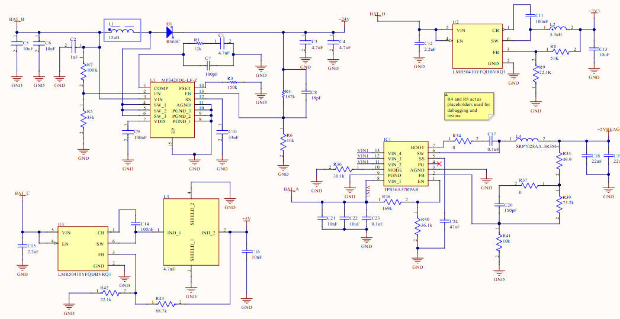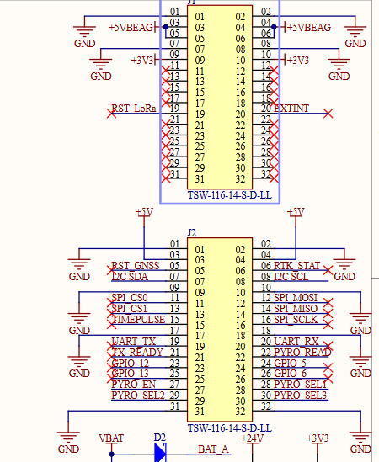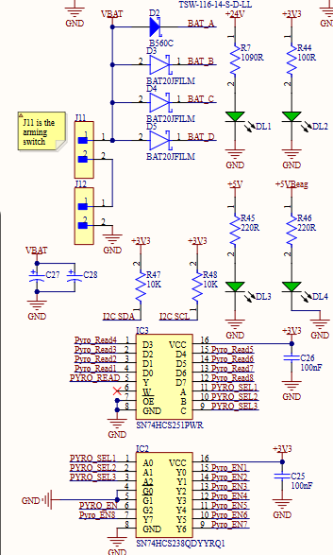

Sensor Board
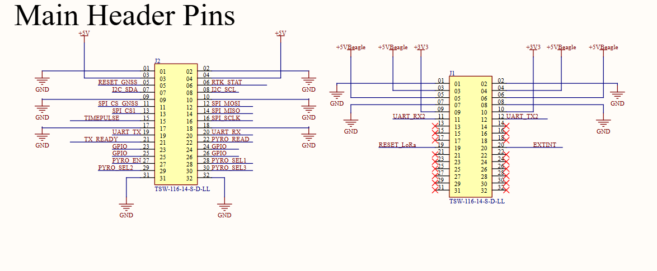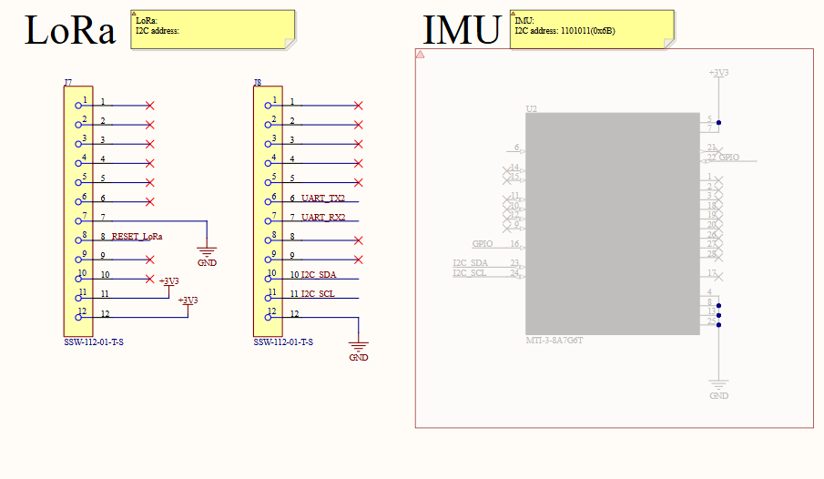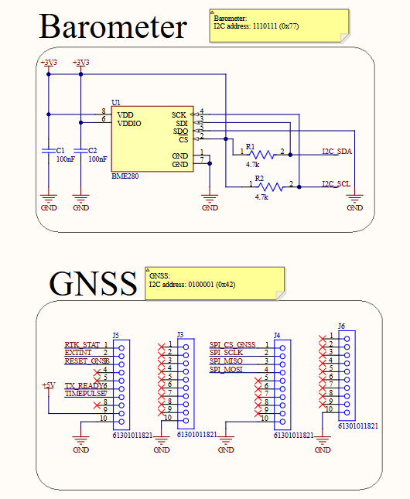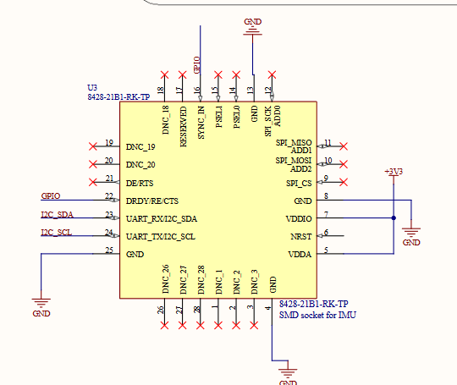

GNSS Board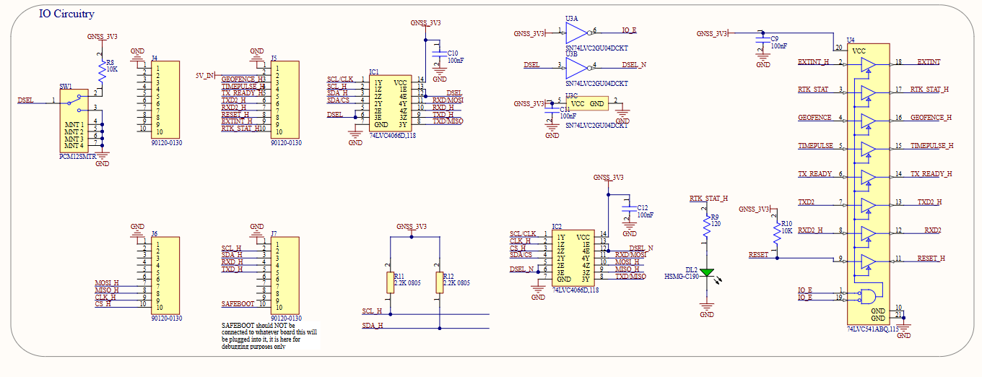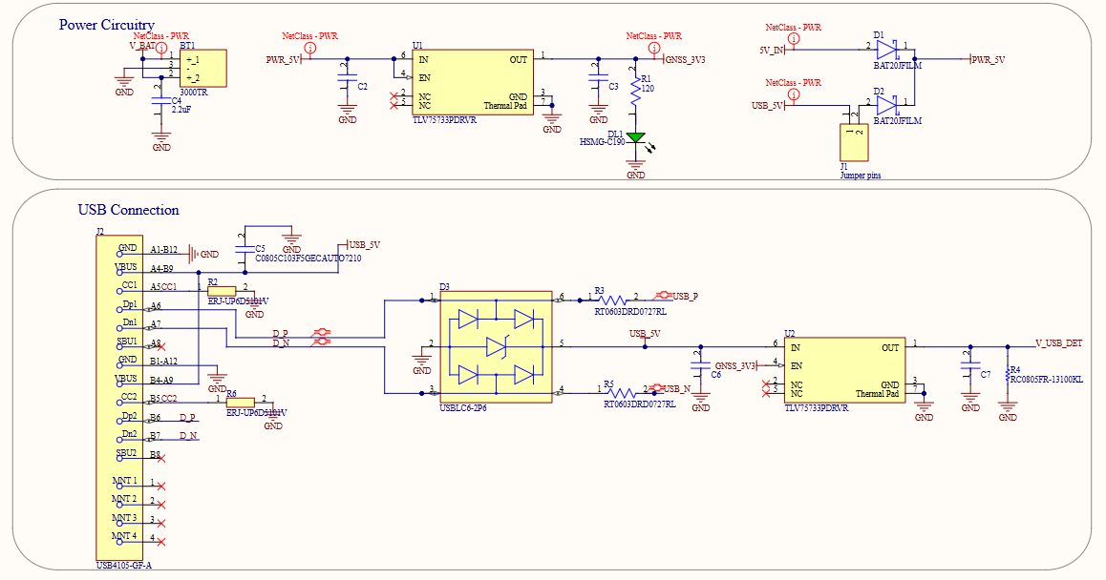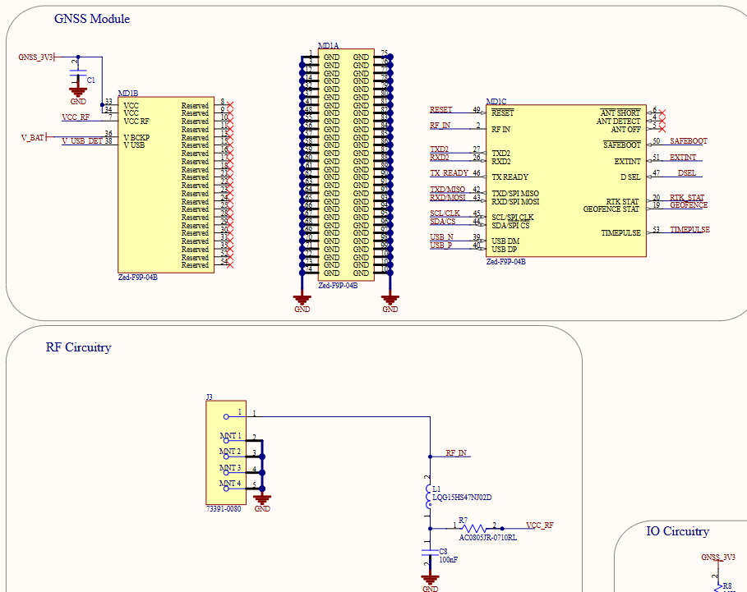

Main Flight Computer

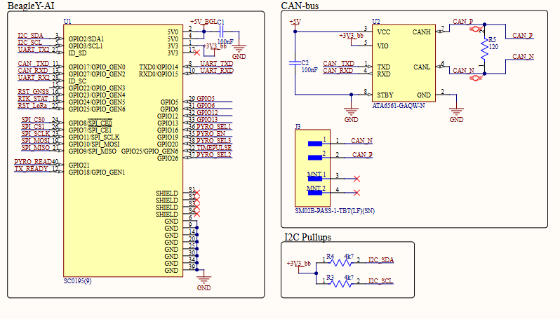

Redundant Flight Computer board